**Assignment Cover Sheet**



|  |  |  |  |
| --- | --- | --- | --- |
| **Qualification:** | Faculty of Information Technology  Bachelor of Science in Information Technology | | |
| **Module code:** | ITEC301 | **Module name:** | Internet Programming and E-commerce |
| **Assignment title:** | E-commerce Website | | |
| **Date:** | 21 March 2018 | **Submission date:** | 21 March 2018 |
| **Student Name:** | Dreyer Morkel | | |
| **Student Number:** | DV2011-0590 | | |

TABLE OF CONTENTS

PROJECT OVERVIEW 3

TARGET AUDIENCE 3

MARKET RESEARCH 4

COMPETITOR 6

PROJECT SCOPE 8

E-COMMERCE PLATFORM 9

BILLING PLAN 10

PORTFOLIO 10

BIBLIOGRAPHY 11

PROJECT OVERVIEW

Introduction

The creation of an E-commerce website is proposed by Goldstone Web Design Cape Town.

Hunter Gatherer started as a pet project of founder Nadine Aucamp in 2009. As a first-year student in Bellville and with money being tight, Nadine liked to visit the nearby Sunshine Shop at the Tygerberg Hospice to look for second-hand clothing that would fit her eccentric personality. She started reselling clothes to her friends and classmates and through word of mouth she was able to start a business.

Hunter Gatherer was born and Nadine continues to run her business using the Hunter Gatherer Online Facebook page. This page is being used to showcase stock and for potential customers to show their interest in items. It is currently the only interface between Nadine and her clients, and is limited to the universal tools available to Facebook users.

Project Objectives

* Meet with the client and obtain requirement needs.
* Analyse these requirements and design a website that best meets the needs of the client.
* Set out a clear project scope that is in line with the budget and schedule of the project. It is important to manage the client’s expectations.
* Select a third-party E-commerce platform to partner with and that suits the needs of the client.
* Develop a usable, functional website that embodies the company through look and feel.
* Deploy and test the product under the supervision of the client to ensure that all needs are met. This may include altering initial requirements and scope.
* Manage the implementation of the new product by selecting the best implementation method to suit the company.
* Provide additional support and maintenance.

Project Summary

The aim of this project is to create an E-commerce website for Hunter Gatherer. The website must be able to accommodate the client to upload items, sell items, and keep track of sales. In this project the developer will be partnering with an E-commerce platform to handle hosting, storage, payments as well as other supporting features.

Furthermore, to ensure project success, the client will act as the primary stakeholder and will be involved in any decisions that may affect the outcome of the project. Transparency and communication will be vital pillars in the completion of this project.

TARGET AUDIENCE

Stakeholder Analysis Matrix

|  |  |
| --- | --- |
| Stakeholder Name | Hunter Gatherer |
| Contact Person | Nadine Aucamp |
| Impact | High |
| Influence | High |
| What is important to the stakeholder? | Maintaining the client base, system functionality, project scope, budget, schedule, and the look and feel of the final product |
| How could the stakeholder contribute to the project? | Setting out clear requirements, taking part in the decision-making process, and contributing to the design process |
| How could the stakeholder block the project? | Being inconsistent with the scope of the project, drastically influencing the schedule and budget, and having unrealistic expectations |
| Strategy for engaging the stakeholder | Initial brainstorming sessions followed by monthly information and feedback meetings |

MARKET RESEARCH

E-commerce has taken decades to become an established and trusted form of shopping. The success of this platform and the rise of the smartphone has allowed M-commerce to become even more popular in a matter of years. M-commerce, or Mobile commerce, refers to the use of mobile devices to conclude business transactions. Being a form E-commerce, these transactions occur over an internet connection, however the technological growth in the field of M-commerce has opened different avenues to the user in the form of native – and hybrid mobile applications. Online transactions have become much more accessible and as a result has grown into the multi-billion dollar market as it is known today.

According to Bhragava, the main difference between E-commerce and M-commerce is the device on which it can be accessed. This may not seem that important at first, but with the aim being to make it as easy as possible for the consumer to make transactions, M-commerce offers a range of features unavailable to E-commerce. Mobility is the biggest advantage of M-commerce, no longer does the consumer have to sit at a desktop computer or laptop to shop online, this can be done using a smartphone or tablet on the go. This automatically makes the service more accessible to a larger demographic of consumers and allows for a more personalised experience. M-commerce continues gain a strong foothold in the E-commerce market and is estimated to become the most popular means of online shopping in years to come (Bhragava, 2017).

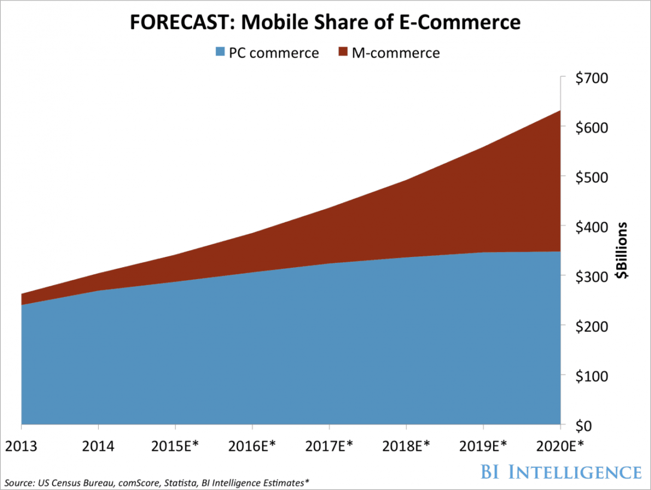

(BI Intelligence, 2016)

Tiburca suggests that there are five key trends that are currently at the forefront of M-commerce. These trends are:

1. Mobile messengers
2. Augmented reality
3. Single-click payments
4. Automation; and
5. Storefront applications (Tiburca, 2017).

Mobile messengers and customer service ‘chatbots’ refer to consumers interacting with artificial intelligence (AI) driven programs using natural language. This technology has certainly not been perfected as of yet, but interest has been shown by market leaders and it has been touted as the future of customer service. These ‘chatbots’ are designed to seek information from the user and to assist with menial tasks. In a study done by van Eeuwen, it is shown that millennials are neutral to the idea of using these messengers and further research estimates that the technology will be largely accepted in the future (van Eeuwen, 2017).

Augmented reality (AR) solutions allow consumers to virtually preview how a product would fit into a personal space. Thus furthering the personalisation aspect of M-commerce. Much like ‘chatbots’, AR is still in its infant stage as a feasible technology and Boyajian suggests that it is seen more as a novelty. However, the practical applications of this technology continues to grow. It is highlighted that AR delivers increased value to a M-commerce application as consumers spend more time engaging with the product and the brand. This in turn, allows the consumer to become more invested in the product and more confident in the purchase (Boyajian, 2017).

Single-click payments has been the pinnacle of usability when it comes to M-commerce. This process was patented by *Amazon* in 1999 and involves the consumer entering their billing, shipping and payment information just once when installing a M-commerce application and then allowing purchases to be made with the single click of a button. The patent expired in 2017, but gave Amazon a major advantage over their rivals. There was some initial doubts over security aspects of this idea, but as mobile devices have become much more secure this idea has become a standard in M-commerce.

Automation has always been a part of technology as a whole and it has been no different in the field of E-commerce. Most additional features of M-commerce applications are already being automated, such as the aggregation of reviews, shopping cart time-outs, and with the use of ‘chatbots’, even customer service. Recently automation has been used in much more inspired ways when it comes to mobile marketing and advertisement. Automated advertising has become the norm on most social media platforms and retailers are encouraged to take full advantage. A study done by Khalaf et al shows that the average American spends more than five hours a day on their mobile devices and that 92% of that time is accounted for by applications (Khalaf et al., 2017).

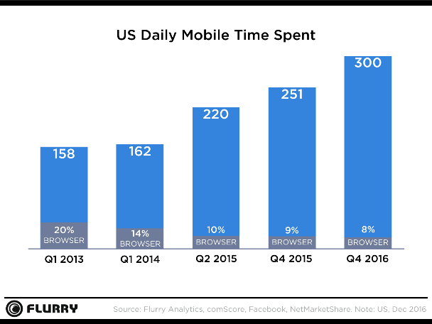 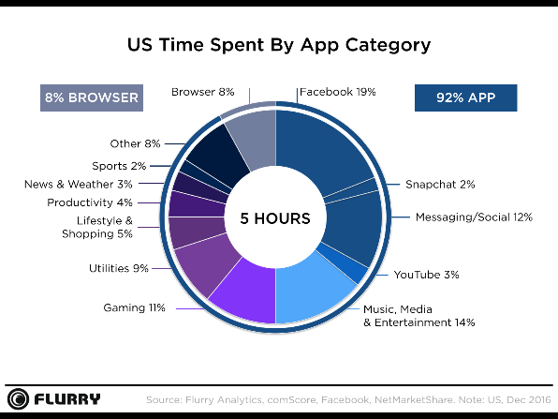

(Flurry Analytics, 2016a) (Flurry Analytics, 2016b)

Most of the advantages of M-commerce that have been discussed within this proposal is based on storefront applications. Having the consumer install an application on their mobile device allows for the use of mobile messengers, augmented reality, single-click payments, and automated advertising. Furthermore, it allows for a personalised user experience and customer retention through the use of push notifications.

COMPETITOR

Vintage PE

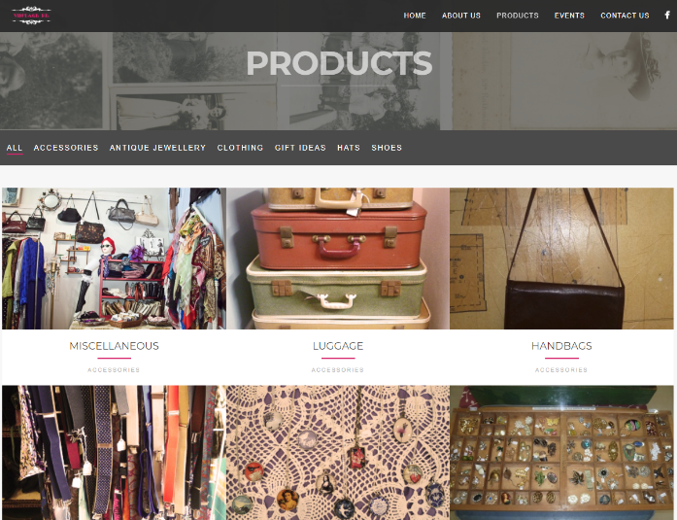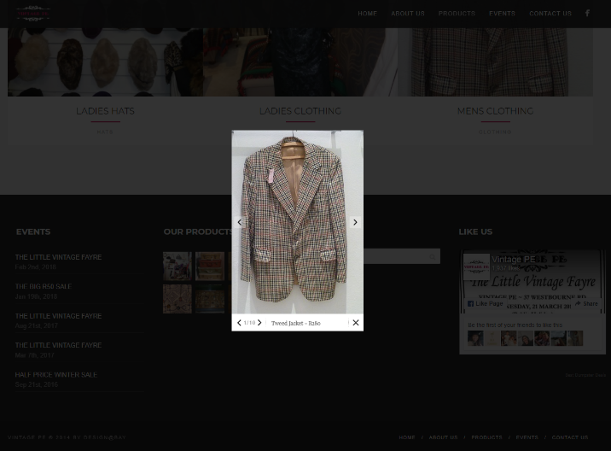

(www.vintagepe.co.za)

Vintage Lover

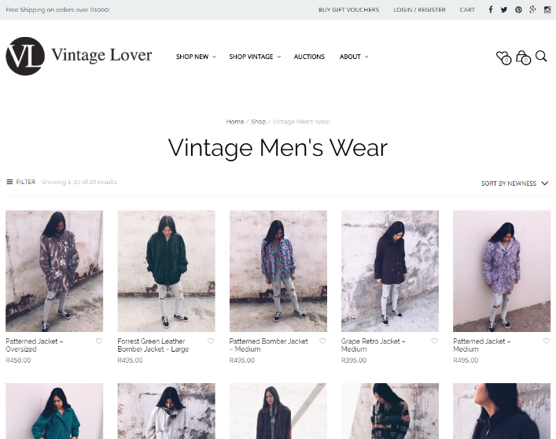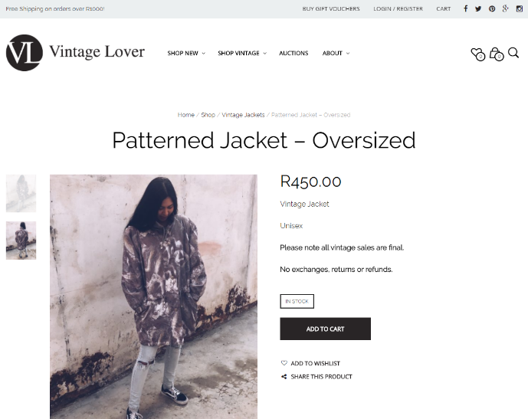

([www.vintagelover.co.za](http://www.vintagelover.co.za))

Oh So Retro

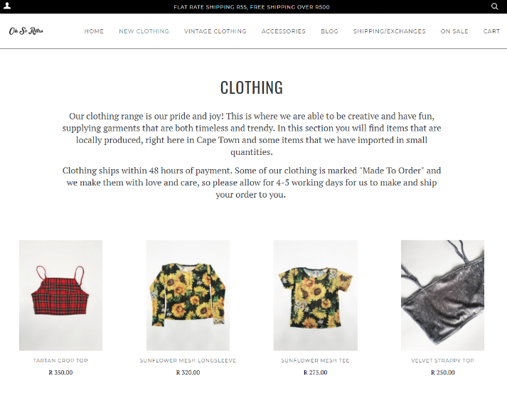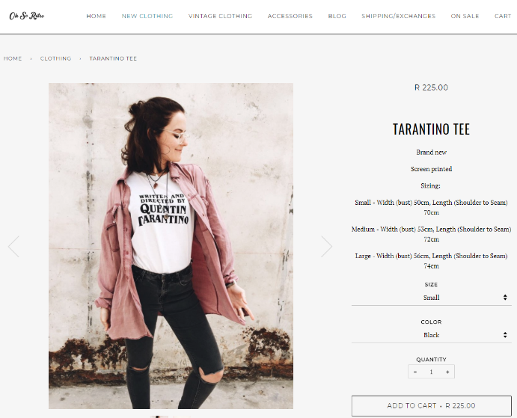

(www.ohsoretro.co.za)

Competitive Analysis

|  |  |  |  |  |
| --- | --- | --- | --- | --- |
|  | Hunter Gatherer | Vintage PE | Vintage Lover | Oh So Retro |
| Interface | * Inviting, dynamic splash screen on home page * Simple and clean navigation between pages, general product categories * Menu locks to top of page while scrolling * Scales to fit screen size * Clear, clean pictures used to display products | * Colourful and inviting splash screen on home page * Simple and clean navigation between pages * Menu locks to top of page while scrolling * Scales to fit screen size * Busy website filled with pictures | * Colourful dynamic splash screen on home page * Clean menu, but contains a lot of items and sub items * Menu does not lock to top of page while scrolling * Scales to fit screen size * Dynamic pictures used for categories and products | * Inviting splash screen on home page * Dynamic menu which hides itself when scaling down * Menu does not lock to top of page while scrolling * Scales to fit screen orientation, mobile friendly * Clean, clear pictures used to display products |
| Products | * Only sells clothing, but contains a wide variety * Under a hundred listed products * Displays product name, size, price and photo | * Wide variety of products ranging from clothing to luggage * Over a hundred listed products * Displays product name, price and photo | * Only sells clothing, but contains a wide variety * Over a thousand listed products * Displays product name, description, price, availability and various photos | * Sells clothing and accessories, not a wide variety * Under a hundred listed products * Displays product name, price, size and photo |
| Functions | * Product search function * Contact via email * Login/Register | * Product search function * Contact via email | * Product search function * Recently viewed products * Contact via email * Frequently Asked Questions * Login/Register | * Product search function * Related to product list * Login/Register * Subscribe to newsletter * Frequently Asked Questions |
| Shopping Cart | * Shopping cart | * No shopping cart | * Shopping cart * Wishlist | * Shopping cart |
| Social Integration | * Link to Facebook and Instagram | * Link to Facebook | * Link to Facebook, Twitter, Pinterest, Google+ and Instagram * Able to share link to product on social media | * Gallery of Instagram posts that link to Instagram page |
| Secured Payments |  | * No payment functionality | * Makes use of the *PayFast* payment solution | * Makes use of the *Shopify* E-commerce platform |

PROJECT SCOPE

Usability documents

* Navigation Pane
* Home page
* Inviting, dynamic splash screen
* Updateable news column
* About Us
* Synopsis of the company’s aim and objectives
* Brief introduction to the founder
* Clothing
* Categorised by clothing sets
* Brief description of the set
* Individual photos of each clothing item
* Contact Us
* In-browser email function for any questions or feedback
* Links to social media pages (Facebook and Instagram)
* User privileges and roles
* Admin
* Account created server side by website administrator
* Forwarded to administration page when logging in
* Account used to create clothing sets and add/remove items
* Able to update news column on home page
* Unable to make purchases with this account
* Able to change password
* User
* Account created by using the registration function
* Makes use of email address as identification
* Makes use of user selected password as authentication
* Able to make purchases with this account
* Able to change password

Content

* Font, Colour and Graphics
* Based on existing Hunter Gatherer Online Facebook page
* Clean, readable web fonts used
* Colour used sparingly to promote simplicity
* Make use of neutral colours so not to clash with clothing/accent photos
* Interactivity
* Newsletter subscription
* Most recent set uploaded
* Social bookmarking
* Feedback form to gather information
* Site search engine

Functionality

* Locally hosted and maintained
* User friendly content management
* Shopping cart
* Forms
* Private client access areas
* Social media integration
* Security

Search engine optimisation

* Keywords
* Vintage
* Retro
* Second-hand

E-COMMERCE PLATFORM

Comparison matrix

|  |  |  |  |
| --- | --- | --- | --- |
|  | Shopify | BIGCOMMERCE | PayFast |
| Shopping | * Secure transactions: Certified Level 1 PCI DSS compliant * Shipping: Able to set up custom shipping zones via 3rd party shipping applications * Taxes: Automatically handled * Order tracking: Part of platform | * Secure transactions: 3D Secure * Shipping: Able to set up custom shipping zones * Taxes: Able to manually define tax rates * Order tracking: Part of platform | * Secure transactions: Certified Level 1 PCI DSS compliant * Shipping: Makes use of 3rd party shipping applications * Taxes: No support * Order tracking: Forms part of shipping module |
| Storage | * Data stored and organised on a cloud, storage limit set per account type | * Data stored and organised on a server using WebDAV Folder Structure | * Data storage not supported |
| Accounts | * Basic Shopify: $29 pm * Shopify: $79 pm * Advanced Shopify: $299 pm | * Standard: $29.95 pm * Plus: $79.95 pm * Pro: $249.95 pm * Enterprise: Custom pricing | * Free sign-up, PayFast receives commission on each sale |
| Payments | * Shopify Payments only available in United States, Canada, United Kingdom, Ireland, Australia, New Zealand, and Singapore | * Makes use of payment gateways per country * The payment gateways supported in South Africa are 2Checkout, NMI, and Skrill | * Credit and cheque cards * Instant EFT * Bitcoin * mobicred * ATM debit cards * Masterpass |
| Support | * Inventory management * Product reports * Google Analytics * Traffic reports * Support team * Discussion forums | * Partner Marketplace * Developer Documentation * Support team * Troubleshooting articles * Discussion forums | * Support team |

Hunter Gatherer is a small business that is being run part-time. The requirements of the E-commerce platform are therefore quite simple. Currently sales are being made via EFT and shipping is done manually. Therefore I would suggest to partner with PayFast as the E-commerce platform.

As seen in the comparison above, PayFast has the least amount of features and support. However, it also requires no monthly subscription fee, rather relying on commission per sale. This fits perfectly to the needs of the client. Furthermore, PayFast is a South African based company and is therefore more acclimatised to the local market. A third-party shipping application may be added to the PayFast solution, or the client may choose to continue handling product shipping manually.

Website and database maintenance will be handled by Goldstone Web Design Cape Town.

BILLING PLAN

Hunter Gatherer E-commerce Website

|  |  |
| --- | --- |
| DELIVERABLES | COST |
| Web design | R 1 500.00 |
| Database design | R 1 500.00 |
| Web development | R 4 000.00 |
| Training | R 500.00 |
| Total | R 7 500.00 |
| ADDITIONAL PAYMENTS |  |
| Hosting | R 100.00 per annum |
| Maintenance | R100.00 per hour |

Payments to be made in four installations, per the completion of each deliverable as listed above. A deliverable will not be made available until payment has been received in full.

Hosting costs will commence on the date of website deployment (to be confirmed by client).

Maintenance fees will be handled via additional invoices as needed.

I, Nadine Aucamp, hereby argee to this billing plan as set out by Goldstone Web Design Cape Town.

_____________________________

PORTFOLIO

Goldstone Web Design Cape Town is a digital consultancy based in Cape Town, South Africa providing a wide range of online services and solutions including Web Design, Website Hosting and E-commerce solutions. We are focused on start-up and small businesses and strive to help business owners find the perfect solution to fit their exact needs.

Meet the team!

|  |  |
| --- | --- |
| Dreyer Morkel | CEO and Business Analyst |
| Chris Viljoen | Front-end Developer |
| Barend du Toit | Back-end Developer |
| Helene Haarhoff | Graphic Designer |
| Nico Lombard | Technician |
| Eduard le Roux | Support Services |

BIBLIOGRAPHY

Advertising Solutions Web Design. (2018). eCommerce Website Design Packages | Advertising Solutions Web Design. [online] Available at: https://advertisingsolutions.co.za/web-design/e-commerce-website-design-packages/ [Accessed 21 Mar. 2018].

Bigcommerce. (2018). BigCommerce: Ecommerce Platform & Shopping Cart Software. [online] Available at: https://www.bigcommerce.com/ [Accessed 21 Mar. 2018].

Bisits Bullen, P. (n.d.). Stakeholder Analysis Matrix Template. [online] Tools4dev.org. Available at: http://www.tools4dev.org/resources/stakeholder-analysis-matrix-template/ [Accessed 19 Mar. 2018].

BI Intelligence (2016). FORECAST: Mobile Share of E-Commerce. [image] Available at: http://www.businessinsider.com/mobile-commerce-shopping-trends-stats-2016-10 [Accessed 20 Mar. 2018].

Bhragava, K. (2017). What is the Difference Between eCommerce and mCommerce?. [online] Medium. Available at: https://medium.com/magenative/key-differences-between-e-commerce-and-m-commerce-ecf880f6d261 [Accessed 20 Mar. 2018].

Boyajian, L. (2017). The future of augmented reality & mobile commerce. [online] www.retailcustomerexperience.com. Available at: https://www.retailcustomerexperience.com/blogs/the-future-of-augmented-reality-mobile-commerce/ [Accessed 20 Mar. 2018].

Flurry Analytics (2016a). US Daily Mobile Time Spent. [image] Available at: http://flurrymobile.tumblr.com/post/157921590345/us-consumers-time-spent-on-mobile-crosses-5 [Accessed 20 Mar. 2018].

Flurry Analytics (2016b). US Time Spent By App Category. [image] Available at: http://flurrymobile.tumblr.com/post/157921590345/us-consumers-time-spent-on-mobile-crosses-5 [Accessed 20 Mar. 2018].

Khalaf, S., Kesiraju, L., SVP and Analytics Manager (2017). U.S. Consumers Time-Spent on Mobile Crosses 5 Hours a Day. [online] Flurry Blog. Available at: http://flurrymobile.tumblr.com/post/157921590345/us-consumers-time-spent-on-mobile-crosses-5 [Accessed 20 Mar. 2018].

Nielsen, J. (2012). The Most Important Usability Activity. [online] Nielsen Norman Group. Available at: https://www.nngroup.com/articles/the-most-important-usability-activity/ [Accessed 21 Mar. 2018].

PayFast. (2018). South Africa's Secure Online Payment Gateway | PayFast. [online] Available at: https://www.payfast.co.za/ [Accessed 21 Mar. 2018].

PixelPunks Digital Media | Web Design Cape Town. (2018). Web Design Cape Town | Premium Web Design, SEO & Ecommerce. [online] Available at: https://pixelpunks.co.za/ [Accessed 21 Mar. 2018].

Shopify. (2018). Ecommerce Software - Best Ecommerce Platform Made for You - Free Trial. [online] Available at: https://www.shopify.co.za/ [Accessed 21 Mar. 2018].

Tiburca, A. (2017). 5 Trends That Are Changing The Face Of M-Commerce. [online] The Next Web. Available at: https://thenextweb.com/contributors/2017/08/30/5-trends-changing-face-m-commerce/ [Accessed 20 Mar. 2018].

van Eeuwen, M. (2017). Mobile conversational commerce: messenger chatbots as the next interface between businesses and consumers. University of Twente.